**Virtual Warehouse overview**

To run anything we need compute resource which is nothing but a Virtual Warehouse.

It would be the first thing we have to set up once we set up snowflake account

**Virtual warehouse = cluster of compute nodes (resources)/machines**

Cluster => group of nodes/machines connected together

Compute Resources => CPU + Memory+ Temporary storage

Machine/computer/node

**Snowflake Warehouse comes in various T-Shirt sizes**



XS(1) will have one compute nodes/machines, S(2) will have 2 compute nodes, M(4), L(8), XL(16), 2XL(32), 3XL(64), 4XL(128) -- generally available

5XL(256) and 6 XL(512) are in preview state

MAXIMUM CLUSTER AS 10 => 128x10 =1280

If we set 6XL warehouse to Multicluster Warehouse=> 512x10 =5120 computes nodes

You can start & stop the warehouse anytime as Snowflake storage & computing are de coupled (separate and independent)

What are Auto-suspension and Auto-resumption?

A warehouse can be set to automatically resume or suspend, based on activity:

* By default, auto-suspend is enabled. Snowflake automatically suspends the warehouse if it is IDLE for the specified period of time 10 minutes
* By default, auto-resume is enabled. Snowflake automatically resumes the warehouse when any statement that requires a warehouse is submitted
* Auto-suspend and auto-resume apply only to the entire warehouse and not to the individual clusters in the warehouse.

**Horizontal and Vertical scaling in Snowflake**

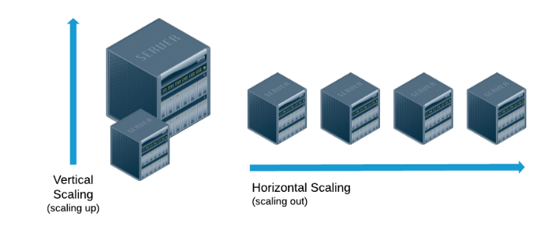

**Vertical Scaling (Resizing the warehouse)**

Scale up => **increasing the warehouse size** example from small => large, M to XL

**Purpose** is to **increase performance** of complex queries

An increase in T-Shirt size (XS⇾XL) => increase in CPU, Memory, Temporary Storage.

Scale down => **reducing the warehouse size** example from large => small

Scale up and down (Re-sizing warehouse) is manual process

We can modify warehouse-size on the fly even if it is in a **running state**, provided the new size change will only be applicable for newly queued queries and all existing queries will still use old warehouse.

At the time of creation, you can provide the size, multi-cluster attribute (Enterprise & above) & Scaling policy

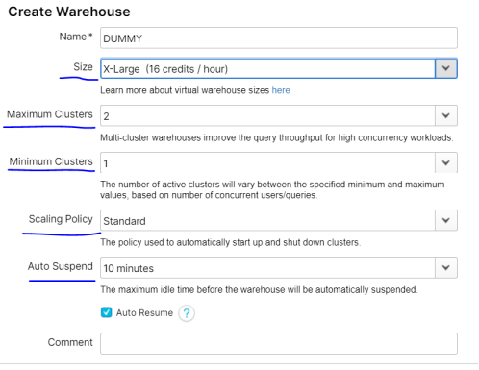

You can modify warehouse size from the Context menu and also modify the min & max cluster under warehouse>config.



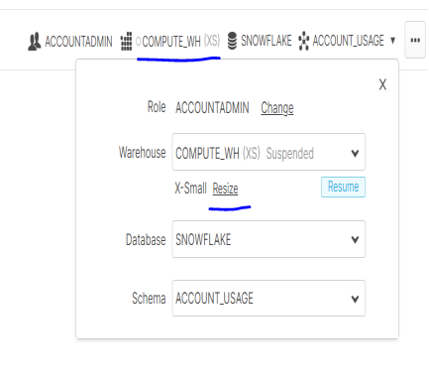

**How to decide on optimum Snowflake Warehouse Size**

Creating multiple warehouses in Snowflake is free, you can create as much as you can, and you will be charged for what you use only.

For each department we can create a warehouse with different size based on workloads

1. Development Team
2. ETL Team
3. Test Team
4. Reporting Team

